Topic No. (select from the category listing) Abstract Reference No: 0000
Oral or Poster (Indicate your preference for Oral or Poster) (Obtained through Website)

MicroTAS 2023 CONFERENCE TEMPLATE AND INSTRUCTIONS FOR ABSTRACT PREPARATION

Zbigniew Brzózka¹, and Elźbieta Jastrzębska¹ and Amy E. Herr²
¹Warsaw University of Technology, Poland
²University of California, Berkeley, USA

The Twenty Seventh International Conference on Miniaturized Systems for Chemistry and Life Sciences (µTAS) will be held 15 – 19 October 2023 in Katowice, Poland. Authors are invited to contribute original presentations on advances in application of and technologies for miniaturized components and systems for chemical and biochemical analysis.

The µTAS 2023 Technical Program Committee encourages submission of original work that contains significantly novel material for either oral or poster presentation. If the subject matter in the abstract appears in print or on the Internet on or before 1 October 2022, it will be rejected.

Submitted abstracts should be two pages: one text page (500 words or less, 11-point font) and one page of figures and tables on either A4 Standard (21 cm x 29.7 cm) or US Standard (8.5 x 11 inches). If your abstract exceeds the 500-word limit, it will not be possible to upload and submit your abstract. The title, topic (selected from the category listing), authors, affiliations and all text must fit on the first page. The second page should contain all figures or tables. References may go on either page. All other style formatting is up to the authors.

The purpose of an Abstract submitted to µTAS 2023 is to inform the Technical Program Committee which new results you propose to present. Therefore, it is important within the first few sentences to state what your primary result and novelty is. For example: "This paper reports an improved method for processing large volume liquid samples containing pathogenic microbial DNA.” It is also important to identify how the new work differs from previous work of your own group and other groups, especially work presented at recent and upcoming international meetings. For example: "The fabrication process for the accelerometer was reported at MEMS ‘19 [1], and an analysis of the new piezoresistor pattern, which accomplishes the reduction in cross-axis sensitivity, will be reported at Transducers 2019 [2]. Our method differs from that of group X [3] in the specific method of temperature compensation we are using, and of group Y [4] in the geometry of the piezoresistor design and placement within the structure."

After an introduction of the basic ideas and how the work relates to other work, please, present detailed descriptions of methods, device structures, and examples of specific results, whether experimental or theoretical. Figures and Tables can support these results. For example: "A schematic view of the genomic DNA is shown in Figure 1, with a close-up detail of the PCR results and placement in Figure 2. A cross-section of the fabrication process is shown in Figure 3. Table I shows the simulations for specific device geometries using the analysis procedure in [2]." After presentation of results, it is useful to benchmark specific results against related work and to comment on the broader impact of the results.

Please make sure that all the figures/photographs are clearly visible. The fact that the program committee cannot clearly see and understand the role of visual aids will be viewed negatively. All submitted abstracts will be considered for both, Oral and Poster Sessions, unless the submitting author specifically requests a Poster.

Word Count: 498

Figure 1: Conceptional sketch of xxx showing

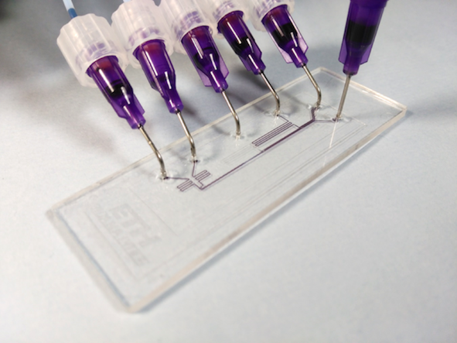

Figure 2: Photograph of the chip xxx in 300 dpi

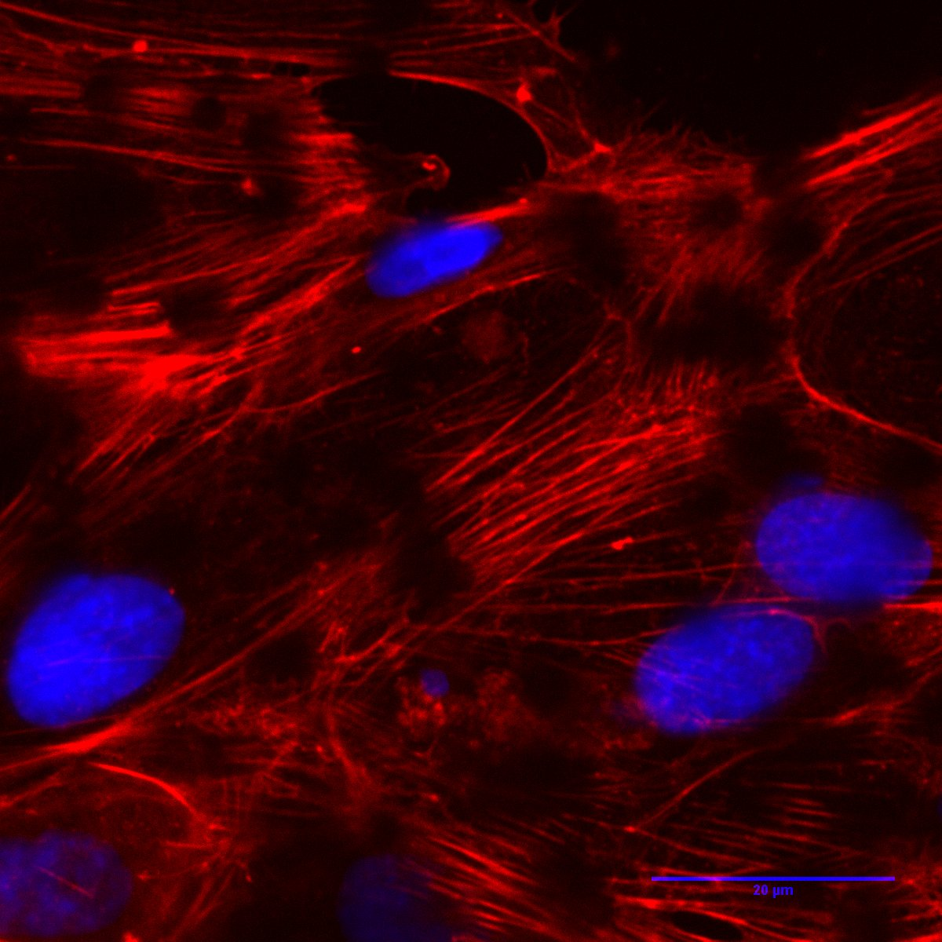
Figure 3. Micrograph of xxxxxxxxx cells

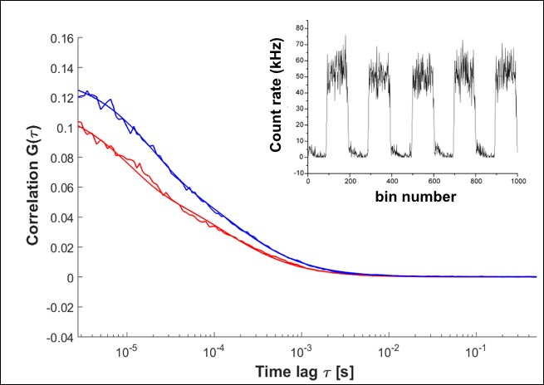

Figure 4: DATA, Results of xxxxxxxxxx

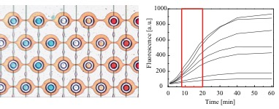
Figure 5. Chip design and results obtained for xxx
Table 1. Example of a table
Table Head | Table Column Head
 | Table Column Subhead | Subhead | Subhead
Copy | More table copy

REFERENCES

- Manz, A., Graber, N., Widmer, H. M., "Miniaturized Total Chemical Analysis Systems: A Novel Concept for Chemical Sensing," Sensors and Actuators B: Chemical, 1990, 1, 244 .
- Whitesides, G.M. “The Origin and Future of Microfluidics,” Nature, 2006, 442, 368.
3. Terry, S. C. , “A Gas Chromatography System Fabricated on A Silicon Wafer Using Integrated Circuit Technology,” PhD thesis Stanford University (USA), 1975.

